ASSIGNMENT 2
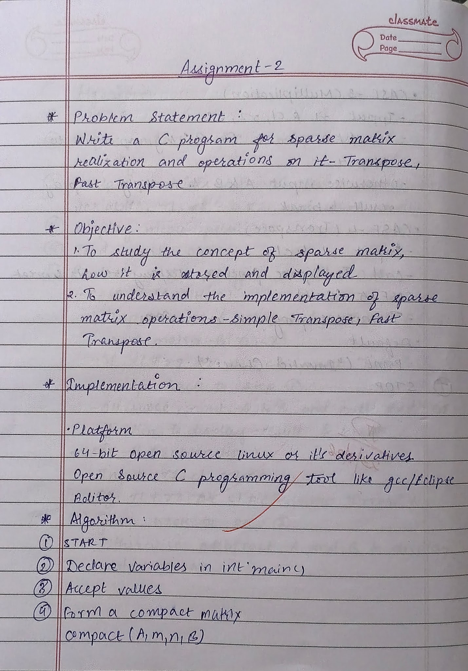
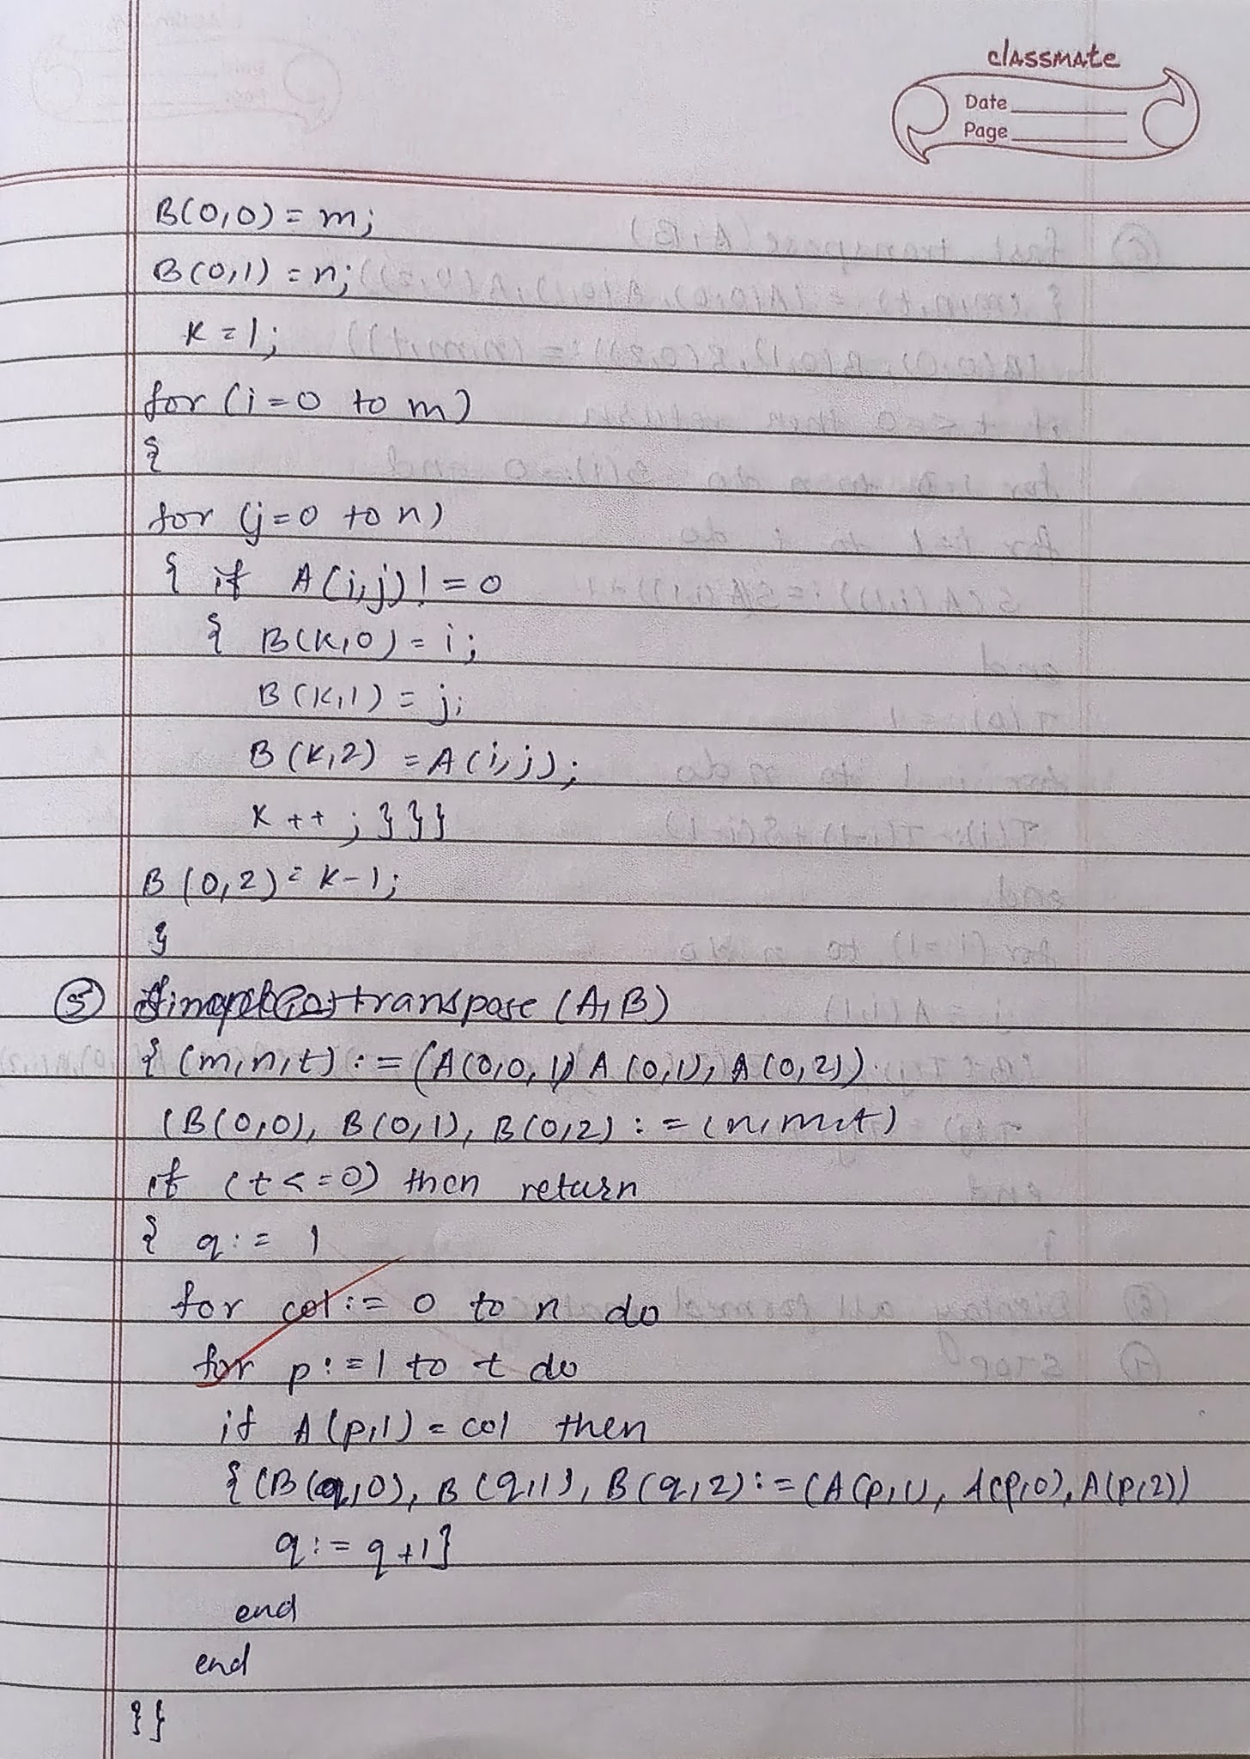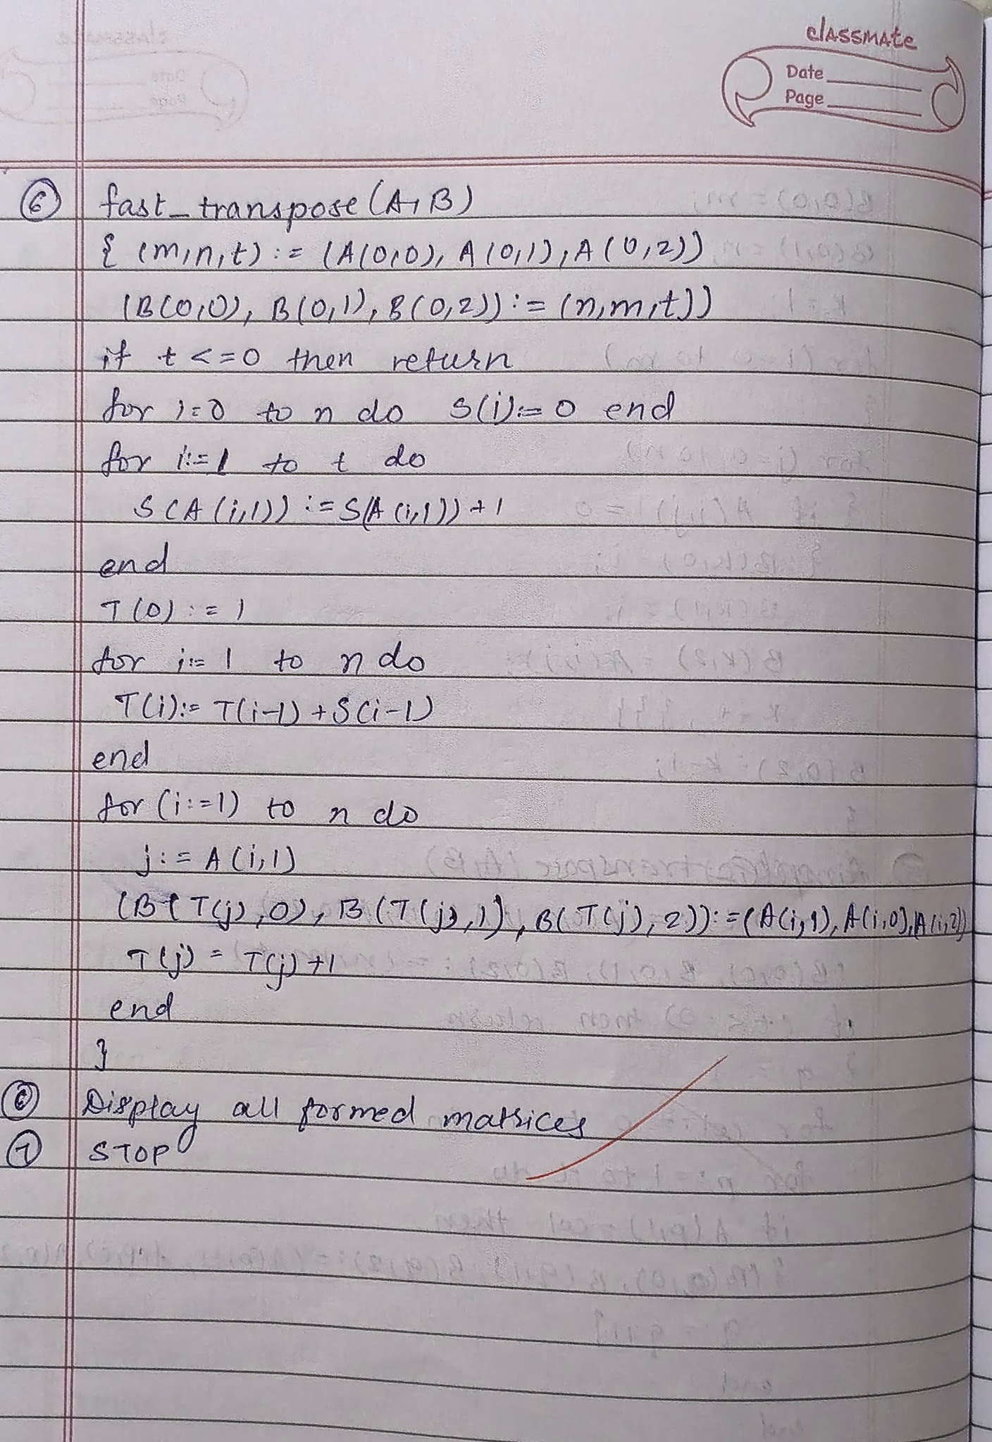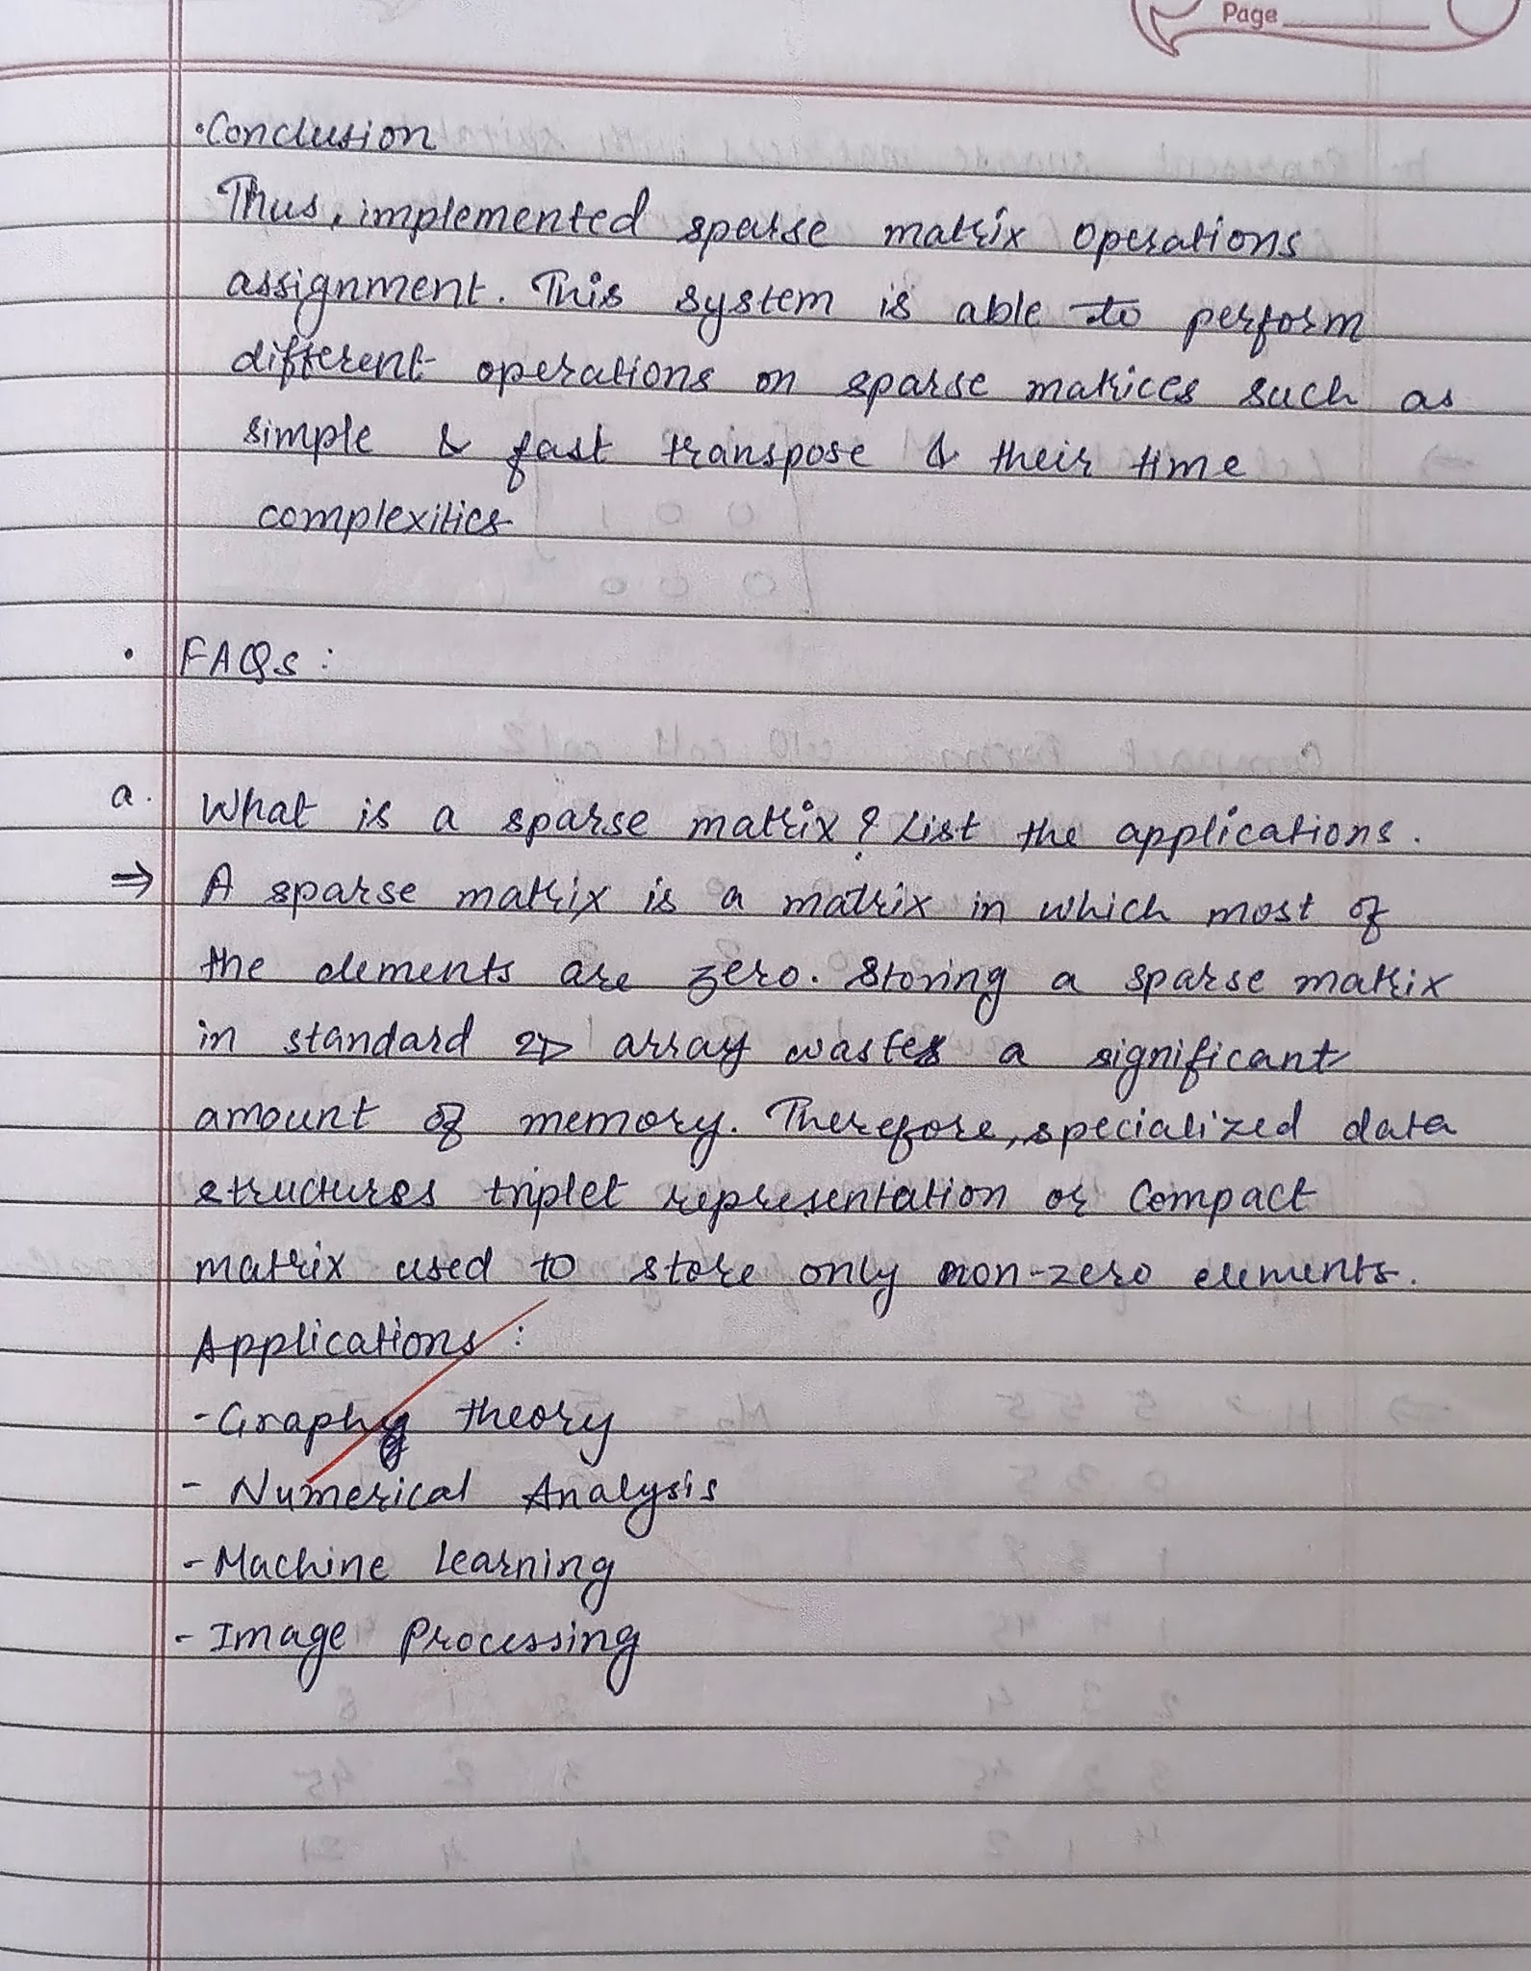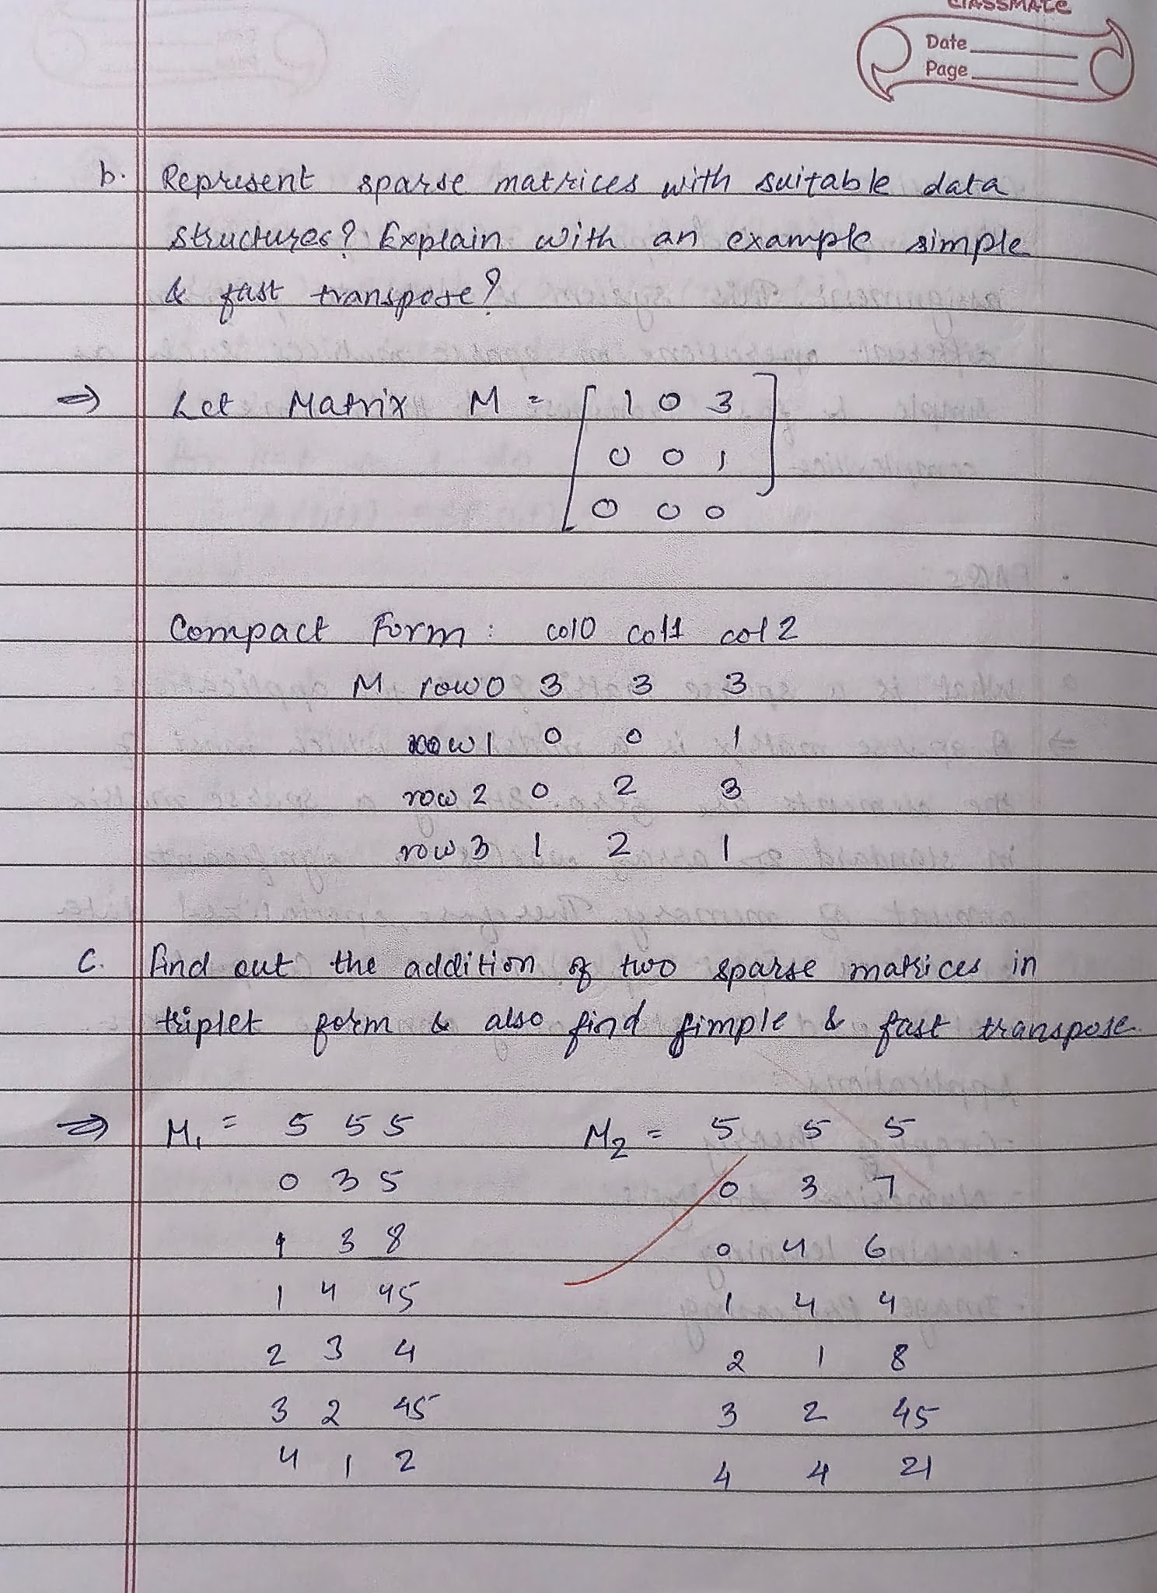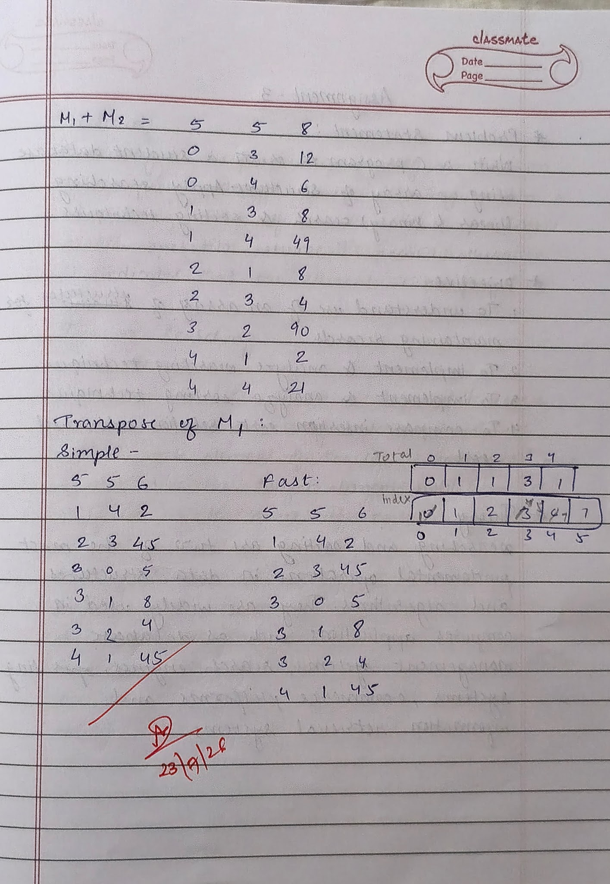

CODE :
include <stdio.h>
#define MAX 100
int main()
{
int a[20][20];
int sparse[MAX][3], trans[MAX][3], fast[MAX][3];
int rows, cols;
int i, j, choice;
int zeros = 0, nonzeros = 0;

printf("Enter number of rows and columns: ");
scanf("%d%d", &rows, &cols);

printf("Enter matrix elements:\n");
for(i = 0; i < rows; i++)
{
for(j = 0; j < cols; j++)
{
scanf("%d", &a[i][j]);

if(a[i][j] == 0)
zeros++;
else
nonzeros++;
}
}

if(zeros <= nonzeros)
{
printf("\nMatrix is NOT Sparse.\n");
return 0;
}

printf("\nMatrix is Sparse.\n");

int k = 1;
sparse[0][0] = rows;
sparse[0][1] = cols;

for(i = 0; i < rows; i++)
{
for(j = 0; j < cols; j++)
{
if(a[i][j] != 0)
{
sparse[k][0] = i;
sparse[k][1] = j;
sparse[k][2] = a[i][j];
k++;
}
}
}

sparse[0][2] = nonzeros;

do
{
printf("\n----- MENU -----");
printf("\n1. Display Triplet Form");
printf("\n2. Simple Transpose");
printf("\n3. Fast Transpose");
printf("\n4. Exit");
printf("\nEnter your choice: ");
scanf("%d", &choice);

switch(choice)
{
case 1:

printf("\nTriplet Form:\n");
for(i = 0; i <= nonzeros; i++)
{
printf("%d\t%d\t%d\n", sparse[i][0], sparse[i][1], sparse[i][2]);
}
break;

case 2:

trans[0][0] = cols;
trans[0][1] = rows;
trans[0][2] = nonzeros;

k = 1;

for(i = 0; i < cols; i++)
{
for(j = 1; j <= nonzeros; j++)
{
if(sparse[j][1] == i)
{
trans[k][0] = sparse[j][1];
trans[k][1] = sparse[j][0];
trans[k][2] = sparse[j][2];
k++;
}
}
}

printf("\nSimple Transpose:\n");
for(i = 0; i <= nonzeros; i++)
{
printf("%d\t%d\t%d\n", trans[i][0], trans[i][1], trans[i][2]);
}
break;

case 3:

{
int total[20] = {0};
int index[20];

fast[0][0] = cols;
fast[0][1] = rows;
fast[0][2] = nonzeros;

for(i = 1; i <= nonzeros; i++)
total[sparse[i][1]]++;

index[0] = 1;

for(i = 1; i < cols; i++)
index[i] = index[i-1] + total[i-1];

for(i = 1; i <= nonzeros; i++)
{
int pos = index[sparse[i][1]];

fast[pos][0] = sparse[i][1];
fast[pos][1] = sparse[i][0];
fast[pos][2] = sparse[i][2];

index[sparse[i][1]]++;
}

printf("\nFast Transpose:\n");
for(i = 0; i <= nonzeros; i++)
{
printf("%d\t%d\t%d\n", fast[i][0], fast[i][1], fast[i][2]);
}

break;
}

case 4:
printf("\nProgram Ended.\n");
break;

default:
printf("\nInvalid Choice!");
}

} while(choice != 4);

return 0;
}

OUTPUT :
